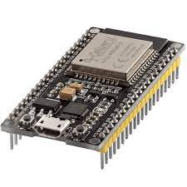**Variant 1: With power supply**

**Controller: ESP32**

The ESP32 development board is a 32-bit SoC (System on Chip) that includes Wi-Fi and Bluetooth communication and has, among other features, 4Mb of flash memory.

Value: 4-7 USD

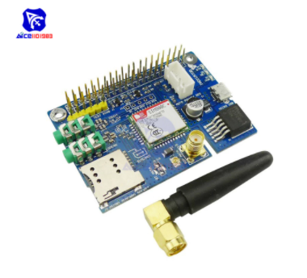

**Communication: GSM-GPRS module**

Mobile phone network module that works in the frequencies of 900MHz or 2100 MHz (2G and 3G in Cuba) and is powered by 5V. Or be quad band which includes the 900MHz frequency.

Value: 6-10 USD.

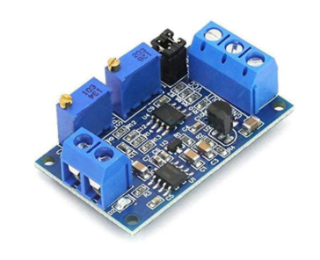**4-20mA to 0-3.3V converter**

Signal Converter and Voltage Transmitter Module, 0 -20mA/4 -20mA to 0-3.3V/0 -5V/0 -10V, Voltage Current Module.

Value: 1-2 USD

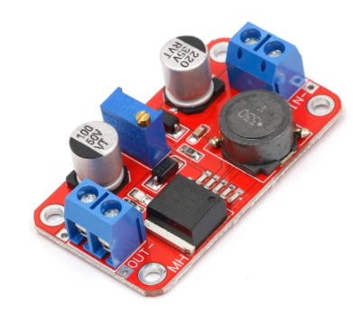 **Power boost module**

Converter from 3.3V-35V to 5V, 6V, 9V, 12V, 24V, XL6019.

Value: 1-2 USD

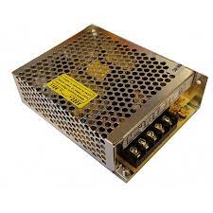

**Power supply**

Power supply with 100 - 240V input and 5V output with 5A.

Value: 8-10 USD

**Variant 2: With Battery and solar panel**

**Controller: ESP32**

The ESP32 development board is a 32-bit SoC (System on Chip) that includes Wi-Fi and Bluetooth communication and has, among other features, 4Mb of flash memory.

Value: 4-7 USD



**Communication: GSM-GPRS module**

Mobile phone network module that works in the frequencies of 900MHz or 2100 MHz (2G and 3G in Cuba) and is powered by 5V. Or be quad band which includes the 900MHz frequency.

Value: 6-10 USD.

**4-20mA to 0-3.3V converter**

Signal Converter and Voltage Transmitter Module, 0 -20mA/4 -20mA to 0-3.3V/0 -5V/0 -10V, Voltage Current Module.

Value: 1-2 USD

 **Power boost module**

Converter from 3.3V-35V to 5V, 6V, 9V, 12V, 24V, XL6019.

Value: 1-2 USD

**Solar panel 5V 1.5W**

**Battery charger module**: includes the lithium battery socket, power boost board, and the TP4056 battery charger.

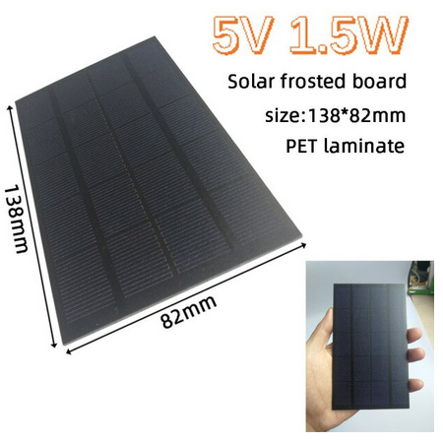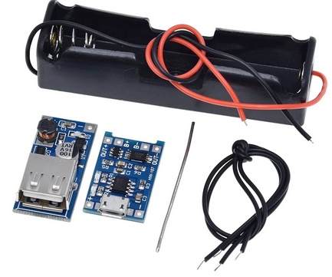

Rechargeable batteries lICR18650 3.7V 9800 mAh

Value: 6 usd

